Roberts Farms Field Trip Form
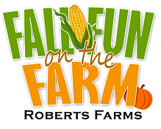
School Name:
School Address:
School Corporation:
Contact Name: Contact Phone Number:
Field Trip Request Dates: 1st: 2nd: 3rd:
Grade Level(s): Number of Classes:
Number of Students: Number of Adults:
Number of Buses: Time Your School Starts:
Estimated Arrival Time: Estimated Departure Time:
Do you plan on eating at the farm? Lunch Snack
If so, what time would you like to eat your lunch/snack?
Admission: $5.00 per person (Adults & Students). Each person visiting will receive a pumpkin or gourd along with a token for a free ice cream to be used on their next visit.
Items Available for Purchase:
Is your group is interested in purchasing the following: (Must know this in advance)
______Ice Cream $1.00 ______Drinks $1.00 (Bottled Water & Pepsi Products)
Additional Requests:
Please email form to haymaze@hotmail.com or call 574-202-2660 with this information. Field trips available first come, first serve. No Monday field trips.
Note: Please bring boxes or have a plan to transport your pumpkins back to your destination.

